Introduction 2
Project Organization 3
Risk Analysis 4
Hardware and Software Requirements 6
Hardware Requirements 6
Software Requirements 6
Work Breakdown 6
UML Diagrams 7
Project Schedule 8
Monitoring and Reporting Mechanisms 8
Appendix 9

Introduction

This project focuses on the design and development of a music player application inspired by early iPod functionality. The application will allow users to import and organize MP3 files by genre, create and manage custom playlists, play individual tracks, and shuffle songs within playlists. Much like classic music devices, this application emphasizes accessibility and intuitive user interaction. It encourages users to quickly navigate their collections and make seamless listening choices. The purpose of this project is to translate the familiar experience of traditional music players into a modern, digital format. Ultimately, this project aims to provide users with both an enjoyable music experience and a deeper understanding of how thoughtful software design enhances everyday interactions.

Project Organization

POSITION | NAMES | DESCRIPTION
Organizer | Ashlie Wyse | Ensures that the team meets the required task to complete the project and keeps all materials in check.
Designer | Jim Klick | Ensures that the software has a simple design that is easy for the project team to implement.
Lead Programmer | Richard Perry | Directs and writes the code for the program.
Junior Programmer | Benjamin Archer | Writes the code for the program.
Tester | Madison Hauptmann | Analyzes and ensures that the program does not have any flaws in its design and that it runs smoothly.

Risk Analysis

RISK | DESCRIPTION | RISK PRIORITY | RISK PLANNING
The product cannot be completed, tested, and delivered in the time allowed. | - Multiple features must be implemented within a limited time.  - Development complexity may slow progress. | High Risk | We will follow a structured development schedule and prioritize core features first. Non-essential features may be reduced if time becomes limited.
The product may experience file corruption or data loss. | - Project files or MP3 test files may be accidentally deleted or corrupted.  - Lack of backups could result in lost progress. | Moderate Risk | We will use cloud storage and version control (github) to regularly back up all project files and reduce the risk of permanent data loss.
The product may fail to properly play audio files. | - Java audio libraries can be difficult to configure.  - MP3 playback may not function correctly across all files. | High Risk | We will research and test reliable libraries early in development and perform frequent testing to ensure playback functionality works correctly.
The product may not meet user expectations for design and usability. | - UI may be confusing or lack visual appeal.  - Poor UX could reduce user satisfaction. | Moderate Risk | We will design a simple, intuitive interface and gather feedback through testing to improve usability and overall design quality.
Playlist functionality may not work correctly. | - Issues with saving, loading, or managing playlists.  - File handling complexity may introduce bugs. | High Risk | We will implement playlist features incrementally and test each function thoroughly to ensure reliability before adding additional features.
The shuffle feature may not behave as expected. | - Randomization may not feel truly random.  - Songs may repeat too frequently. | Low Risk | We will use standard randomization methods and test shuffle behavior to ensure a fair distribution of songs.
Development tools may fail or cause issues. | - IDE crashes or software errors may interrupt development. | Low Risk | We will keep backups and ensure development tools are updated. Work can be resumed quickly after interruptions.
Hardware failure may interrupt development. | - Personal computers may malfunction or become unusable. | Moderate Risk | We will store files in cloud storage so work can continue on another device if needed.
Scope expansion may delay the project. | - Adding extra features beyond requirements may increase workload. | High Risk | We will clearly define the project scope and focus only on required features. Additional features will only be added if time allows.
The application may experience performance issues. | - Large music libraries may slow down loading or playback. | Moderate Risk | We will optimize file handling and test the application with larger datasets to ensure acceptable performance.
Communication problems may affect development. | - Misunderstandings about requirements or features may occur. | Low Risk | We will maintain clear documentation and communicate regularly to ensure all requirements are understood and followed.

Hardware and Software Requirements

Hardware Requirements
- Windows Computer
- Monitor
- Keyboard and Mouse
- Speakers or Headphones

Software Requirements
- Windows Operating System
- Java Runtime Environment
- Standalone application file

Work Breakdown
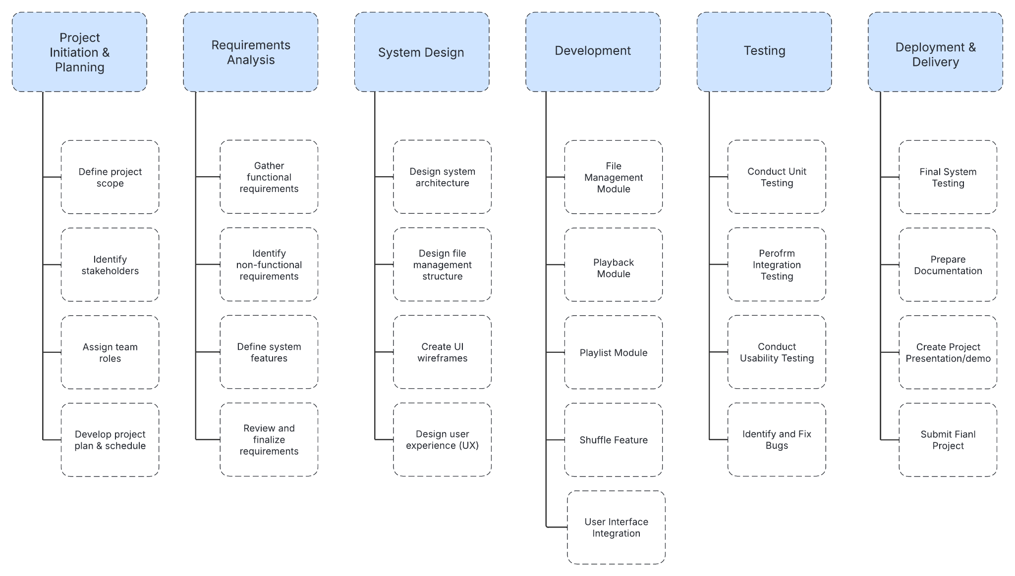

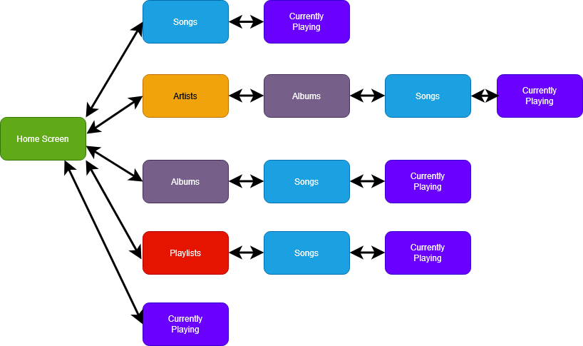
UML Diagrams

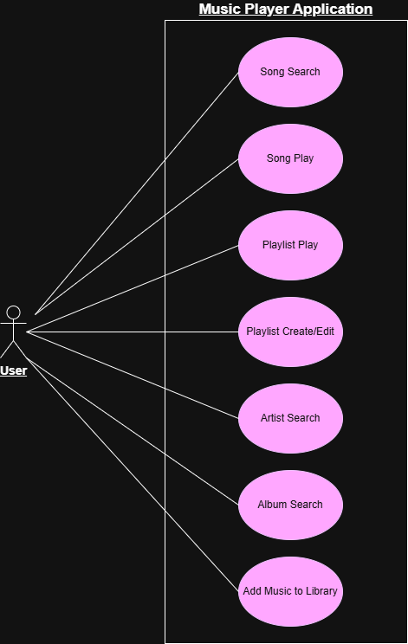

Project Schedule
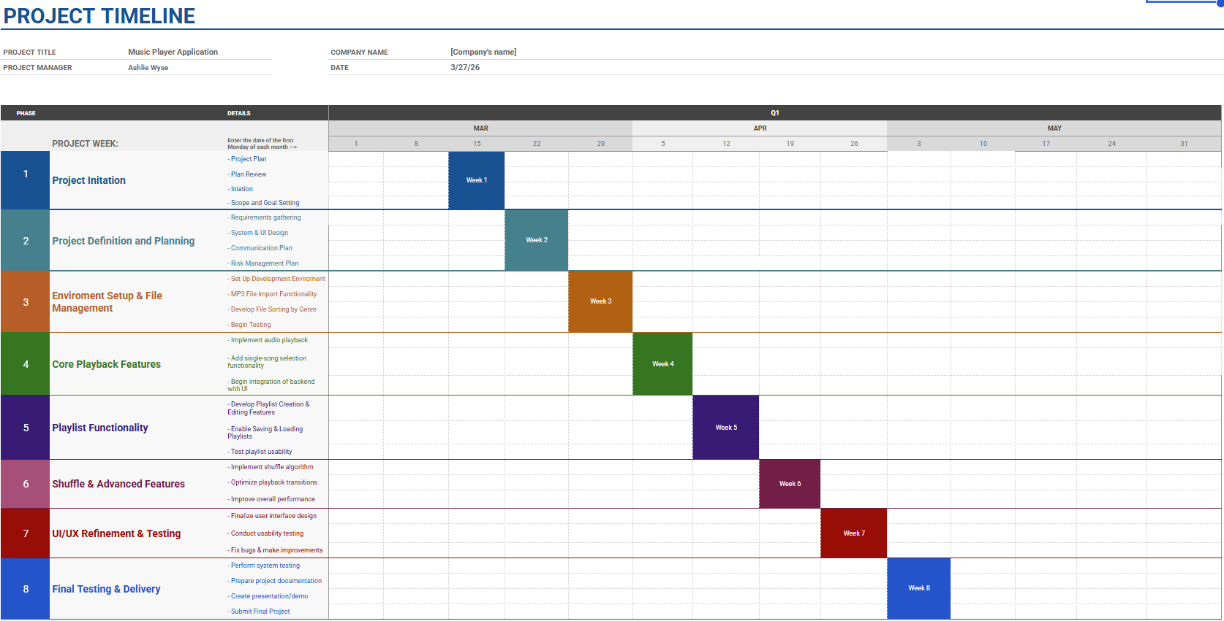

Monitoring and Reporting Mechanisms
Discord
Github
Google Docs
Canvas

Appendix
